**Engineering Specification**

**ER-20015206**

**SPEC, CORIOLIS SENSOR COEFFICIENTS**

**Revision: AP**

**Number of Pages:** 8

**Comments:**

|  |  |
| --- | --- |
| **Originator:** | MTC 5/7/09 |
| **Approved:** | MTC 5/26/09 |

|  |  |  |  |  |
| --- | --- | --- | --- | --- |
| **Rev** | **ECN** | **Description** | **Approval** | **Date** |
| AE | 1042548 | Added CMFHC2Y | MMC | 5/19/11 |
| AF | 1043396 | Added CMF400 & corrected the HC3 coefficients | AWP | 12/12/11 |
| AG | 1047519 | Added K100S K200S K300S | SXU | 12/09/13 |
| AH | 1047715 | Add CMF350M & CMF350A to Chart | DMW | 2/11/14 |
| AI | 1049276 | Add VOS coefficients to K200 and K300 and revise K-series DT, FT and FD values | SXU | 12/02/14 |
| AJ | 1050372 | Add K025S and K050S  Correct CMFHC gas calibration constants  Add F300, reformatted table 1 and added the GasFD coefficient | SXU/AWP | 4/29/15 |
| AK | 1053061 | Updated coefficients to have a slope below 0.4 SG | AWP | 3/15/16 |
| AL | 1055654 | Update flow and density equations | AWP | 9/28/16 |
| AM | 1066811 | Changed name. Added delta T zero 3 description. Add piece-wise linearization. | AWP | 11/22/17 |
| AN |  | Added the new sensor linearization for HC and CMF | AWP | 2/15/2018 |
| AO | 1078135 | Added F300 Enhanced | DWS | 4/6/18 |
| AP | 1078708 | Change F300 Enhanced flow rate | DWS | 4/13/18 |

1. FUNCTIONAL DESCRIPTION:

Engineering specification that defines the Coriolis sensor coefficients that are used in the Mass flow and density equations within MMI’s transmitters.

1. FLOW EQUATIONS:

The mass flow equations consist of measured values, calibration coefficients and calibration constants. The mass flow calibration constants for each sensor design are $m_{ρ}$, GasFD, and $b_{ρ}$ which are listed in Table 4 . Equation 1 is the general mass flow equation. Equation 2 and Equation 3 show the correction coefficients used to compensate mass flow for temperature and density effects. There are two methods for compensating the mass flow rate for density effects; first is the Density Correction Factor, and the second is the Gas Meter Factor for Density. Either method can be used to make corrections to mass flow based on the density of the fluid.

|  |  |
| --- | --- |
| $\dot{m}=FCF∙\left(∆t-{∆t}_{0}+{∆t}_{03}\right)∙\left(1+comp\right)∙TCF∙DCF∙GasFD$ | Equation 1 |
| Where: |  |
| $\dot{m}=Mass Flow \left(\frac{g}{s}\right)$ |  |
| $FCF=Flow Calibration Factor \left(\frac{g}{s}/μs\right)$ |  |
| $∆t=Time Delay (μs)$ |  |
| $∆t_{0}=Zero (μs)$ |  |
| $∆t_{03}=Zero value to compensate for LD effects (μs)$ |  |
| $$GasFD=Gas Meter factor for density correction on mass flow$$ |  |
| $$comp=\text{Compensation for nonlinearities in the flow error vs. flowrate}$$ |  |
| $TCF=1-\frac{FT}{10,000}∙T_{f}$ | Equation 2 |
| Where: |  |
| $FT=Temperature effect on Flow \left(\frac{\%}{100℃}\right)$ |  |
| $T_{f}=Tube \left(fluid\right) temperature \left(℃\right)$ |  |
| $DCF=1+m_{ρ}∙ρ+b_{ρ}$ | Equation 3 |
| Where: |  |
| $ρ=Measured Density \left(\frac{g}{cm^{3}}\right)$ |  |
| $m_{ρ}=Density correction slope \left(\frac{1}{\frac{g}{cm^{3}}}\right)$ |  |
| $b_{ρ}=Density correction offset \left(unitless\right)$ |  |

1. DENSITY EQUATIONS:

The density equations consist of measured values, calibration coefficients and calibration constants. The basic density equation is shown in Equation 4 which includes how the density measurement is compensated for flow effects. Equation 5 shows how the measured tube period is corrected for the effects of temperature.

|  |  |
| --- | --- |
| $ρ=\left(C_{1}∙τ_{c}^{2}+C_{2}\right)- \frac{FD}{{10}^{9}}{∆t}^{2}$ | Equation 4 |
| Where: |  |
| $C_{1}=\frac{D2-D1}{K2^{2}-K1^{2}}$ |  |
| $C_{2}=D1-C_{1}∙K1^{2}$ |  |
| $FD=Flow effect on Density \left(\frac{g/{cm}^{3}}{{μs}^{2}}\right)$ |  |
| $∆t=Time delay \left(μs\right)$ $K1=Calibrated Tube Period for Fluid 1 at 0 °C \left(μs\right)$ $K2=Calibrated Tube Period for Fluid 2 at 0 °C \left(μs\right)$ $D1=Density of Fluid 1 \left(g/{cm}^{3}\right)$ $$D2=Density of Fluid 2 \left(g/{cm}^{3}\right)$$ |  |
| $τ_{c}^{2}=$ $τ_{m}^{2}∙\left(1-\frac{DT}{10,000}∙T_{f}\right)$ | Equation 5 |
| Where: |  |
|  |  |
|  |  |
|  |  |

1. t03 Compensation

Some Coriolis sensors are affected by the LD phenomenon. The t zero 3 (t03) coefficient is designed to lessen the LD effect. The LD non-linearity is compensated in the Coriolis mass flow equation by adding an additional amount of zero into the flow equation. The logic tree for how the amount is added is shown in Figure 1. The values for the (t03) are a type coefficient and is only enabled for the meters listed in Table 1.

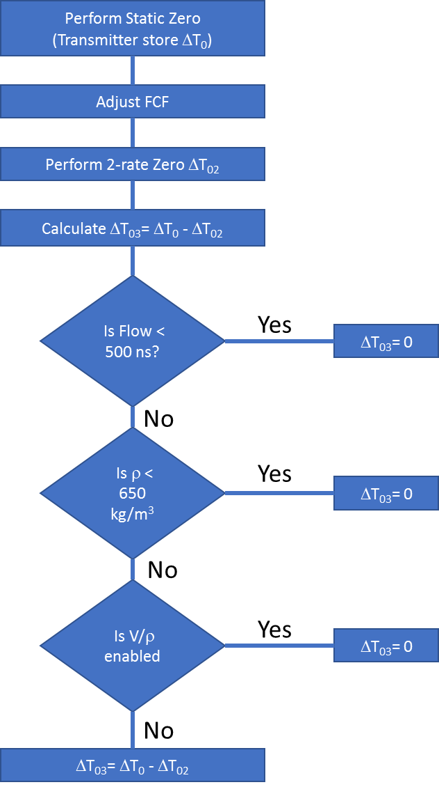

Figure : Logic tree for the t03 algorithm

Table : t03 type coefficients

|  |  |
| --- | --- |
| Sensor Model | t03 (ns) |
| CMF350 M/P/H | 4 |

1. Flow non-linearity compensation

Certain Coriolis meters have non-linearities in mass flow rate error as a function of flowrate. The non-linearity is compensated for in the transmitter using a piece-wise linearization. There are two distinct methods for the linearization. The first method is to correct nonlinearities for small meters. The small meter non-linearity correction uses more points to correct an apparent sine wave pattern to the mass flow data. Data for the small meter compensation is listed in Table 2.

Table : Small Meter Piece-Wise Linearization Type Coefficients

|  |  |  |  |
| --- | --- | --- | --- |
| Sensor Model | Fluid density (g/cc) | Flow rate (kg/s) | Comp small |
| CMFS007 M | < 0.95 | 0 | 0.0000 |
| 0.0077 | 0.0000 |
| 0.0116 | 0.0025 |
|  |  |  |  |
| CMFS10 M/P/H | < 0.95 | 0.0000 | 0.0000 |
| 0.0014 | -0.0015 |
| 0.0083 | -0.0010 |
| 0.0166 | 0.0032 |
| 0.0250 | 0.0012 |
| 0.0305 | -0.0002 |
| 0.0350 | -0.0015 |
| 0.0400 | -0.0025 |
| >0.95 | 0.0000 | 0.0000 |
| 0.0060 | -0.0012 |
| 0.0151 | 0.0000 |
| 0.0227 | 0.0012 |
| 0.0272 | 0.0012 |

The second non-linearity correction method is for large sensors. The large meter correction is to eliminate the need to perform a two rate zero in the SSC. Customers and calibration labs around the world do not perform two rate zeros, they just perform a push button zero. This enables the use of push button zero’s to be used with meters that have L/D effects on water. The logic for turning on the large meter correction is shown in Figure 2. The coefficients for the large meter compensation is listed in Table 3.

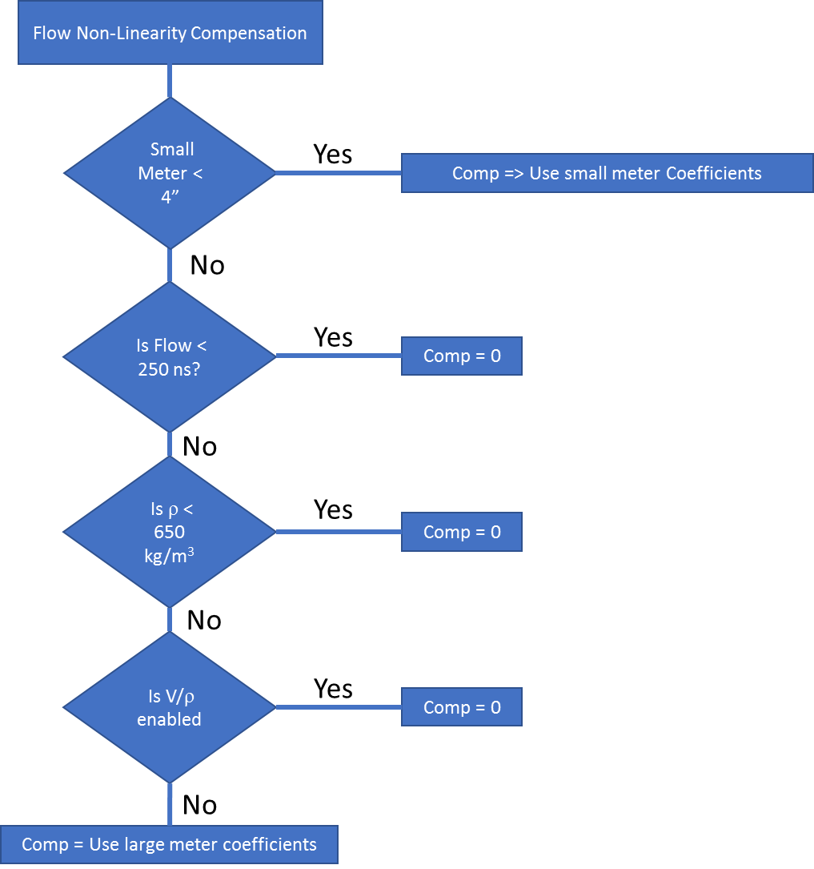

Figure : Logic tree for flow non-linearity compensation

Table : Large Meter Piece-Wise Linearization Type Coefficients

|  |  |  |
| --- | --- | --- |
| Sensor Model | Flow rate (kg/s) | Comp Large |
| F300 Enhanced | 0.0 | 0.00000 |
| 1.3 | 0.00200 |
| 7.7 | 0.00125 |
| 19.2 | 0.00047 |
| 38.7 | 0.00000 |
| CMF400 | 0.0 | 0.00000 |
| 4.2 | 0.00200 |
| 20.8 | 0.00090 |
| 54.2 | 0.00057 |
| 129.2 | 0.00000 |
|  |  |  |
| CMFHC2 | 0.0 | 0.00000 |
| 9.7 | 0.00095 |
| 41.3 | 0.00066 |
| 108.3 | 0.00024 |
| 208.3 | 0.00000 |
|  |  |  |
| CMFHC3 | 0.0 | 0.00000 |
| 1.7 | 0.00110 |
| 46.7 | 0.00090 |
| 75.0 | 0.00030 |
| 283.3 | 0.00000 |
|  |  |  |
| CMFHC4 | 0.0 | 0.00000 |
| 4.2 | 0.00460 |
| 20.8 | 0.00100 |
| 75.0 | 0.00055 |
| 183.3 | 0.00000 |
|  |  |  |

1. CALIBRATION CONSTANTS:

Table :  Coefficients for DCF and GASFD

|  |  |  |  |  |  |
| --- | --- | --- | --- | --- | --- |
| Sensor Model | GasFD  ≤0.4 |  |  |  |  |
| ≤0.4 | | >0.4 | |
| F300 Enhanced | 1 | .003 | -.0012 | 0 | 0 |
| F300[S,H] | 0.986 | 0 | 0 | 0 | 0 |
| K200[S] | 1 | 0.0223 | -0.0089 | 0 | 0 |
| K300[S] | 1 | 0.0415 | -0.0166 | 0 | 0 |
| CMF350[M,A] | 1 | 0.01 | -0.004 | 0 | 0 |
| CMF400[A,M, H,P] | 1 | 0.0225 | -0.009 | 0 | 0 |
| CMFHC2[A,M,Y] | 1 | 0.0137 | -0.006 | 0.0008 | -0.0008 |
| CMFHC3[A,M,Y] | 1 | 0.0207 | -0.009 | 0.0013 | -0.0012 |
| CMFHC4[A,M] | 1 | 0.0292 | -0.013 | 0.0021 | -0.0022 |